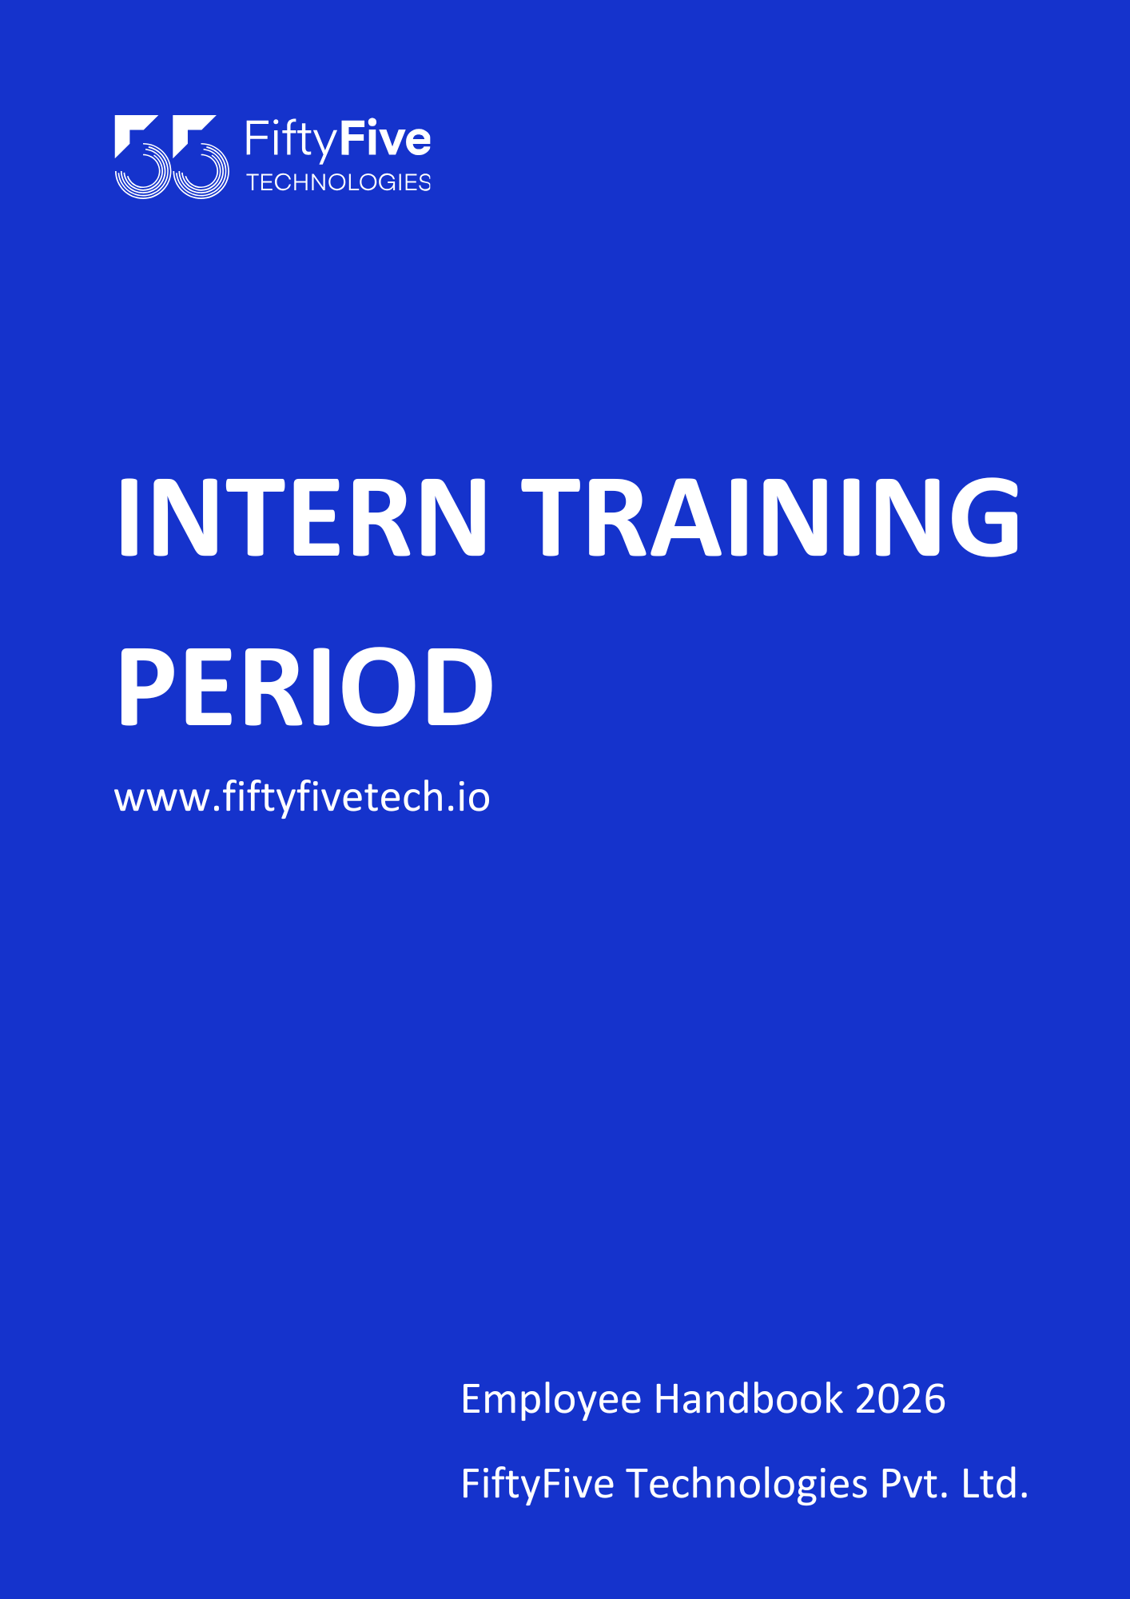

FiftyFive Policy - Intern Training Period
Document Release Notice

This FiftyFive Technologies Policy on trainee period is released for use in FiftyFive Technologies Pvt Limited with effect from 01 January 2026.
This document is subject to FiftyFive Technologies Pvt Limited Procedure and subject to change any time as per the company policy.
Approved By: Jyothi Sharma (CEO-FiftyFive Technologies Pvt. Limited)
Approved By: Sanchi Saxena (Head HR-FiftyFive Technologies Pvt Limited)

Introduction

Intern Training Period
FiftyFive Technologies has a mandatory Intern Training Period that every Intern joining the organization is required to undergo. This Intern Training Period enables the Intern to clearly understand their role, goals, responsibilities, and performance expectations aligned with FiftyFive’s standards. Upon successful completion of the Training Period, the Intern may be confirmed as a permanent employee, subject to satisfactory performance and business requirements.

Purpose
The purpose of this policy is to ensure that every Intern joining FiftyFive Technologies undergoes a structured Intern Training Period that helps them understand their roles, responsibilities, goals, and expected performance standards. This policy aims to facilitate smooth onboarding, assess the Intern’s suitability for the role, align individual performance with organizational objectives, and ensure readiness for confirmation as a permanent employee upon successful completion of the Intern Training Period.

Applicability
This policy is applicable to all Learning & Industry Exposure, Paid & Unpaid Internship and Training, Student Internship employees of FiftyFive Technologies.
This policy is not applicable to experienced employees of FiftyFive Technologies who possess a minimum of six (6) months of prior work experience at the time of joining the organization.

Definition of Trainees
For the purpose of this policy, Intern Trainees include individuals engaged under Learning & Industry Exposure programs, Paid or Unpaid Internships, Training programs, and Student Internship programs. This definition also covers interns recruited from MBA, B.Tech, or other educational institutions, as well as those engaged through external sources.

Provisions
Paid Internships:
- Employment Status and Termination
During your tenure as an intern employee, your services shall be treated as “probationary” and can be terminated anytime without any notice period or without assigning any reasons. This decision rests entirely with the Company, and the decision of the Company shall be final and binding on you in all respects.

- Stipend Payment
As a gesture of support, the Company may, at its sole discretion, pay a monthly stipend to Interns during the Intern Training Period. The decision to offer a stipend shall be based on the Intern’s performance, role requirements, and business needs, and shall rest entirely with the Company. The decision of the Company shall be final and binding in all respects.
- The stipend, if applicable, shall be paid monthly and will be inclusive of all applicable statutory deductions.
- The stipend structure may vary based on business requirements, role expectations, and the profile of the Intern/Trainee.
- The Company reserves the absolute right to revise, modify, suspend, or withdraw the stipend structure at any time, without prior notice.
- Exit Process for “Interns”
It is hereby clarified and understood that during the probation period, the Company invests significant time, effort, and resources in training and developing the employee, thereby adding value at its own cost. The stipend or remuneration paid during this period is not intended to be full compensation for such investment. Accordingly, if the employee chooses to resign or discontinue services before the completion of the intern training period from the date of joining, the employee shall be required to serve a notice period of two (2) months. This condition shall be legally binding on the employee.
In the event of non-compliance with the notice period requirement, the Company reserves the right to initiate appropriate legal action as deemed necessary. The employee shall be held liable for any fees, costs, expenses, or losses incurred by the Company as a result of such premature separation.

- Leave Policy
- Exam Leave Policy: Interns who are currently pursuing their Graduation or Post-Graduation are eligible to apply for Exam Leave. To avail of this leave, Interns must submit an official examination date sheet issued by their respective college or university as supporting proof via email to their reporting manager, with the HR team marked in CC. The leave request must be submitted at least fifteen (15) days prior to the commencement of the examinations.
Exam Leave shall be approved strictly in accordance with the actual examination dates mentioned in the submitted date sheet. Any additional leave required for examination preparation shall be subject to prior approval from the reporting manager.
- Casual Leave: Every Intern is eligible for six (6) leaves during the Intern Training Period. Interns may apply for leave directly through the KEKA portal.
Leave entitlement shall commence from the date of joining and shall be credited at the rate of one (1) leave per month during the Training Period.
Upon confirmation as a full-time employee, the total annual leave entitlement shall be twelve (12) leaves, inclusive of the six (6) leaves already accrued during the Training Period. The remaining six (6) leaves shall continue to be credited as per the Company’s Full-Time Employee Leave Policy.

- Performance Review
During the Intern Training Period, the Company will closely monitor the Intern’s performance, work quality, work attitude, and availability. Failure to meet the Company’s performance standards or behavioral expectations may result in the Company taking appropriate action, including continuation, extension, or discontinuation of the training engagement, as deemed necessary.
Performance reviews shall be conducted on a monthly or quarterly basis, aligned with the Intern’s date of joining. Subject to satisfactory performance and suitability for the role, the Intern may be considered for confirmation as a full-time employee upon successful completion of a minimum of six (6) months of the Training Period with the Company.

- Company Assets Policy for Interns
Paid Interns may be provided with Company assets such as laptops, mobile devices, software, or other equipment required for their work. These assets remain in the property of the Company and must be used solely for work-related purposes. Interns are responsible for their care, maintenance, and security, and any loss, damage, or misuse may make the Intern financially liable as per the assets policy of the company.
All assets must be returned in full and in working condition upon completion of the internship, termination, or upon request. Interns must also ensure that any data or information accessed through Company assets remains confidential, and any breach of this policy may result in disciplinary action or legal consequences.

- Misconduct or Breach of Service Conditions
In the event that the Intern is found to have engaged in any misconduct, breached any of the Company’s service conditions, or committed any act which, in the opinion of the Company, is prejudicial to the interests of the Company, the Company reserves the right to terminate the engagement with immediate effect and without prior notice.
The Company’s decision regarding the occurrence or determination of any such misconduct or breach shall be final and binding. The Intern shall not be entitled to question or challenge the same on any grounds whatsoever.

- Full-Time Employment Disclaimer
Completion of the Internship/Intern Training Period does not guarantee, confer, or create any right or entitlement to full-time employment with the Company.
Upon successful completion of the program, the Company may, at its sole discretion, evaluate the Intern’s performance, skills, qualifications, and alignment with business requirements.
Subject to the availability of a suitable role and internal approvals, the Company may consider offering full-time employment.
The Intern/Trainee expressly understands and agrees that:
- The Company is under no obligation to offer full-time employment.
- No assurance, promise, or commitment—whether express or implied—has been made regarding permanent employment.
- Any decision relating to full-time employment shall rest entirely with the Company and shall be subject to its internal policies, performance standards, and business needs.
This Internship/Intern Training Period engagement shall not be construed as an offer, assurance, or entitlement to future employment with the Company under any circumstances.

- Completion Certificate
Upon successful completion of the Internship or Intern Training Period, and subject to the fulfillment of all assigned roles and responsibilities, the Company may issue a Completion Certificate acknowledging the duration and nature of the engagement.
Issuance of such Completion Certificate shall be subject to the following conditions:
- Successful completion of the prescribed program tenure.
- Satisfactory performance, conduct, and behavior throughout the engagement.
- Full compliance with the Company’s policies, confidentiality obligations, and completion of all exit formalities.
The Completion Certificate is issued solely for record and reference purposes and shall not be construed as proof of employment, confirmation of permanent engagement, or entitlement to future employment with the Company.
The Company reserves the right to withhold, delay, or deny issuance of such documents in the event of policy violations, misconduct, non-compliance, or incomplete fulfillment of program requirements.

Unpaid Internship:
This internship is offered strictly as an unpaid learning and skill-development engagement. The Intern shall not be entitled to any salary, wages, stipend, leaves, honorarium, allowance, or any other form of monetary or non-monetary compensation for the duration of the internship.
The Intern acknowledges and agrees that participation in this Unpaid Internship is solely for educational, learning, and experiential purposes and does not create an employer–employee relationship or any entitlement to remuneration. Interns are required to use their own laptops or equipment, as no Company assets will be provided.
Upon successful completion of the internship and subject to fulfillment of assigned responsibilities, satisfactory conduct, and compliance with Company policies, the Company may, at its discretion, issue a Completion Certificate.
Issuance of such acknowledgment shall be for record and reference purposes only and shall not be construed as proof of employment, confirmation of permanent engagement, or entitlement to future employment with the Company.

Right to Amend Policies
This Employee Handbook is intended to provide general guidance on Company policies and practices. FiftyFive Technologies reserves the right to amend, modify, suspend, or withdraw any policy, procedure, or benefit described in this handbook at any time, with or without notice, based on business, operational, or legal requirements.



